**Hypothesis Testing**

Q1 A F&B manager wants to determine whether there is any significant difference in the diameter of the cutlet between two units. A randomly selected sample of cutlets was collected from both units and measured? Analyze the data and draw inferences at 5% significance level. Please state the assumptions and tests that you carried out to check validity of the assumptions.

Minitab File : **Cutlets.mtw**

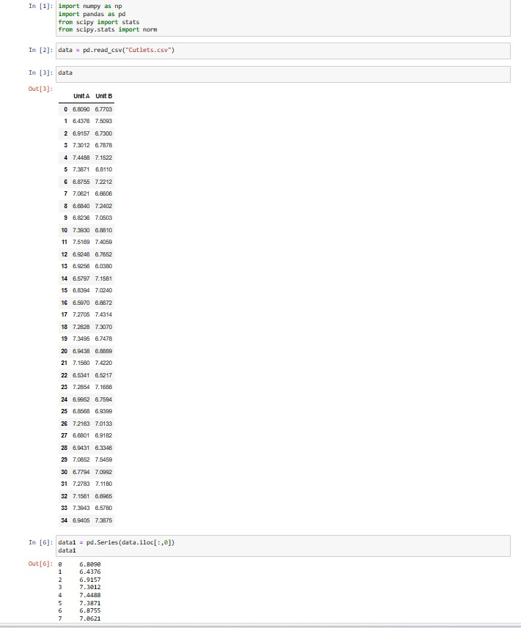

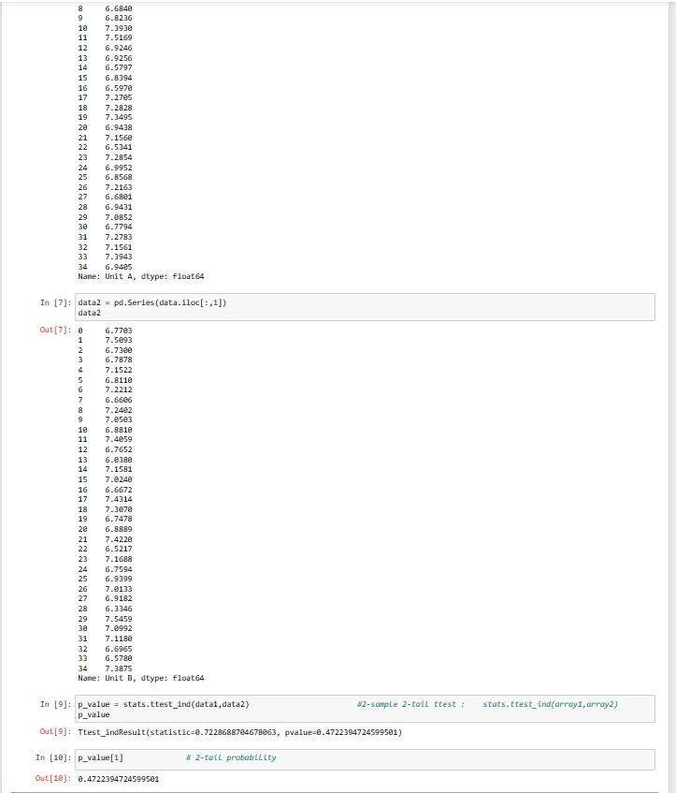

Assumptions :-

* Random Sampling – Make sure the cutlet samples from both units are selected randomly to avoid any bias.
* Independece : Each cutlet’s measurements should be independent of the others.
* Normality : The cutlet diameter data should roughly follow a normal distribution within each unit.
* Homogeneity Of Variance : The variance in cutlet diameters should be similar in both units.

Tests :-

* Null Hypothesis : The mean diameter of cutlets in unit A is equal to the mean diameter of cutlets in Unit B . This can be represented as µ1 = µ2 , where µ1 and µ2 are the population means of the two units.
* Alternative Hypothesis : The mean diameter of cutlets in Unit A is not equal to the mean diameter of cutlets in Unit B . This can be represented as µ1 not equal to µ2.

Q2 A hospital wants to determine whether there is any difference in the average Turn Around Time (TAT) of reports of the laboratories on their preferred list. They collected a random sample and recorded TAT for reports of 4 laboratories. TAT is defined as sample collected to report dispatch Analyze the data and determine whether there is any difference in average TAT among the different laboratories at 5% significance level.Minitab File: **LabTAT.mtw**

Ans :- 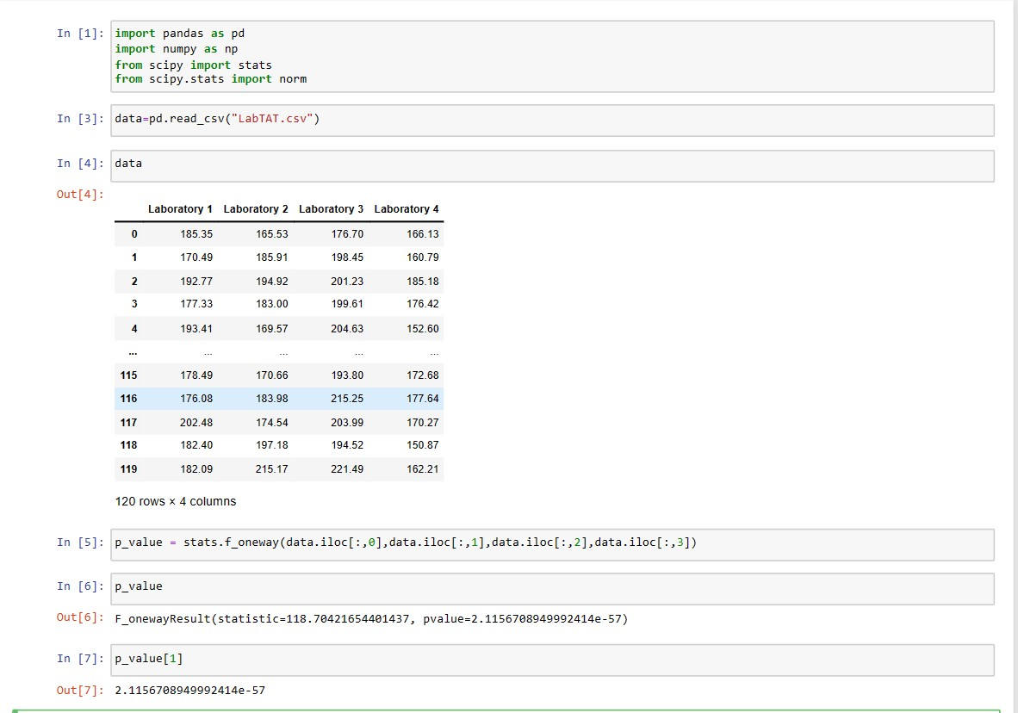

Q3 Sales of products in four different regions is tabulated for males and females. Find if male-female buyer rations are similar across regions.

Ans :- 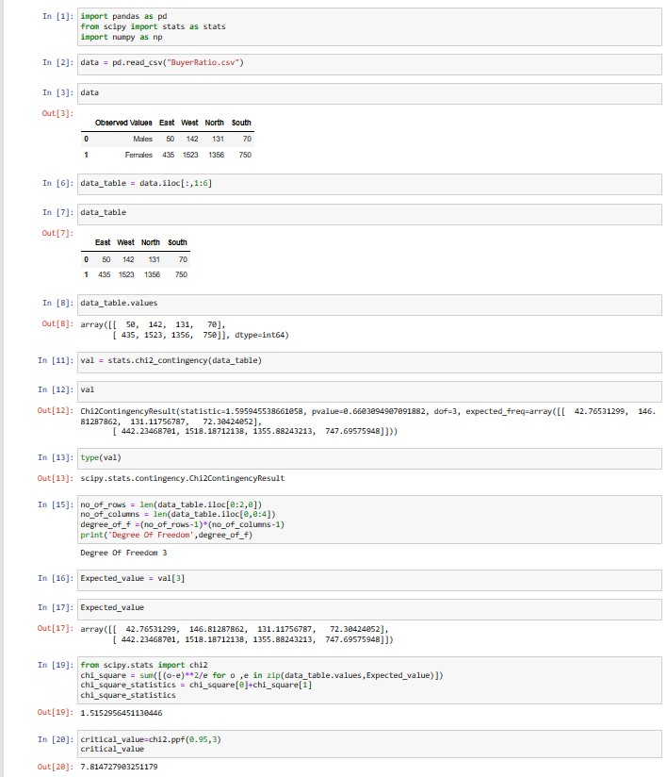

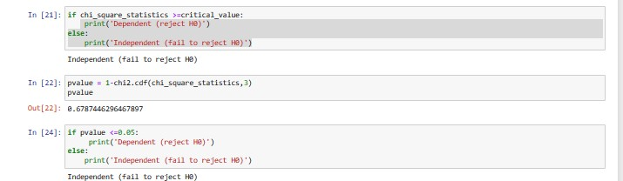

Q4 TeleCall uses 4 centers around the globe to process customer order forms. They audit a certain % of the customer order forms. Any error in order form renders it defective and has to be reworked before processing. The manager wants to check whether the defective % varies by centre. Please analyze the data at *5%* significance level and help the manager draw appropriate inferences

Minitab File: **CustomerOrderForm.mtw**

 Ans :- 